Short Investigation Bulletin

DATE: 21st July, 2022
REPORT #OCC-2021/0036
AIRCRAFT REGISTRATION: N954BZ
INVESTIGATION STATUS: Closed

Summary
Occurrence Bulletins are concise reports that detail the facts surrounding an aviation occurrence, as received in the initial notification and any follow-up enquiries. They provide an opportunity to share safety messages in the absence of a full investigation.

Released as required, the Bulletin provides a summary of the less-complex factual investigation reports conducted by the AAIA. The results, based on information supplied by organizations or individuals involved in the occurrence, detail the facts behind the event, as well as any safety actions undertaken. When applicable, the Bulletin also highlights important Safety Messages for the broader aviation community, drawing on earlier AAIA investigations and research.

General Details

Date and Time of Occurrence: 28th November, 2021; 12:13 PM EST (1713 UTC)
Location Lynden Pindling International Airport (MYNN), Nassau, Bahamas
Persons on Board Crew 1 Passengers 6
Injuries: Crew 0 Passengers 1
Commanders License: Commercial Pilot
Occurrence category: Fuel
Occurrence type: Serious Incident
Investigation status: Closed

Aircraft Details
Aircraft Type and Registration: | Piper PA 31-350, N954BZ
Year of Manufacture & Serial #: | 1978/ 31-7852116
Number and Type of Engine(s) | Two/ Reciprocating
Type of operation: | Commercial
Information Source: | Notification
Nature of Damage: | Broken windows, floor panels and left wing root panel
Occurrence Summary

On November 28, 2021, at 12:13 PM EST (1713 UTC), a Piper Navajo PA-31-350 with United States registration N954BZ, was involved in an occurrence at the Lynden Pindling International Airport (MYNN), Nassau, Bahamas. There were seven (7) souls on board.

The pilot in command of the aircraft reported that during startup of the left engine, there was a loud bang. He immediately then placed both the fuel and throttle levers to cut off position, removing power from the engine and then from the aircraft with the master switch.

On scene investigators observed and documented the damages to panel for the left wing root as well as the cabin forward floorboards and windows of the aircraft.

The floorboards were blown upwards leaving the underlying structure exposed. Multiple cabin windows were blown outward from the aircraft fuselage leaving openings. Observations the left wing root revealed heavy blueish green stains consistent with avgas on and around the fuel bowl and its connecting lines.

One (1) passenger onboard received minor injuries.

A limited scope investigation was conducted, no safety message(s) or recommendation(s) were issued.

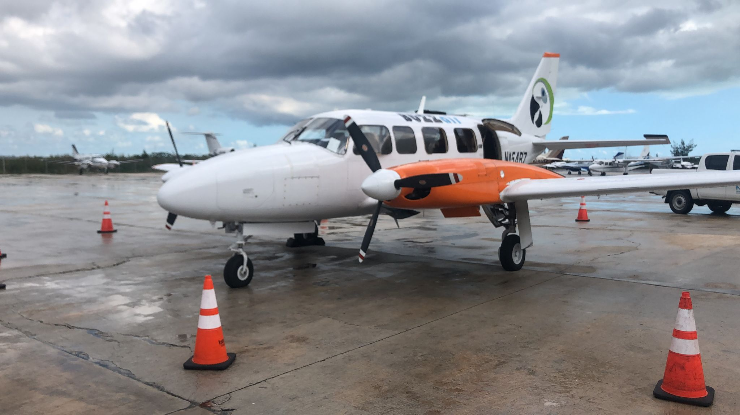

This Occurrence Bulletin contains facts which have been determined up to the time of issue. It is published to inform the aviation industry and the public of the general circumstances of accidents and serious incidents and should be regarded as tentative and subject to alteration or correction if additional evidence becomes available.

All AAIA investigations are conducted in accordance with Annex 13 to the Convention on
International Civil Aviation, and The Aircraft Accident Investigation Authority Act and Regulations The sole objective of the investigation of an accident or incident under these Regulations is the prevention of future accidents and incidents. It is not the purpose of such an investigation to apportion blame or liability. Accordingly, it is inappropriate that AAIA reports should be used to assign fault or blame or determine liability, since neither the investigation nor the reporting process has been undertaken for that purpose.

